Full Stack Development with MERN

Project Documentation

1. Introduction

Project Title
SHOPEZ: E-Commerce Application

Team members
S.No | Team Member | Role
1 | Leela Kanaka Nagalakshmi Illuri | Team Leader & Frontend Developer
2 | Amaleswari Dagani | Backend Developer
3 | Rachabanti Geetha Rani | Frontend Developer
4 | Madhuri Dhana Bhagya Bhisetti | Database Designer
5 | Mulaka Manikanta Reddy | Testing & Documentation

2. Project Overview

Purpose
SHOPEZ is a web-based e-commerce application developed using the MERN Stack (MongoDB, Express.js, React.js, and Node.js). The project provides an online shopping platform where customers can browse products, add items to their cart, place orders, and manage their accounts securely. Administrators can efficiently manage products, categories, customers, and orders.

Features
- User Registration
- Secure Login using JWT
- Product Listing
- Product Search
- Category Filter
- Shopping Cart
- Wishlist
- Order Placement
- Order History
- Admin Dashboard
- Product Management
- User Management
- Responsive Design

3. Architecture

Frontend
The frontend is developed using React.js. It provides a responsive user interface for customers and administrators.
Technologies Used
- React.js
- HTML5
- CSS3
- Bootstrap
- JavaScript
- Axios

Backend
The backend is developed using Node.js and Express.js.
Responsibilities
- User Authentication
- Product Management
- Shopping Cart
- Order Processing
- REST API Development

Database
MongoDB stores the application data.
Collections
- Users
- Products
- Categories
- Cart
- Orders
Database Interaction
React → Express API → MongoDB

4. Setup Instructions

Prerequisites
Install the following software:
- Node.js
- MongoDB Community Server or MongoDB Atlas
- Git
- Visual Studio Code
- Postman

Installation

Clone Repository
git clone https://github.com/yourusername/shopez-ecommerce.git

Install Frontend
cd client
npm install

Install Backend
cd server
npm install

Environment Variables
Create a .env file inside the server folder.
Example
PORT=5000
MONGO_URI=your_mongodb_connection_string
JWT_SECRET=your_secret_key

5. Folder Structure
SHOPEZ/
│
├── client/
│ ├── public/
│ ├── src/
│ │ ├── components/
│ │ ├── pages/
│ │ ├── services/
│ │ ├── App.js
│ │ └── index.js
│
├── server/
│ ├── config/
│ ├── controllers/
│ ├── middleware/
│ ├── models/
│ ├── routes/
│ ├── uploads/
│ ├── server.js
│ └── package.json
│
├── README.md
└── package.json

6. Running the Application

Backend
cd server
npm start
Server runs at
http://localhost:5000

Frontend
cd client
npm start
Application runs at
http://localhost:3000

7. API Documentation
Method | Endpoint | Purpose
POST | /api/auth/register | Register User
POST | /api/auth/login | Login User
GET | /api/products | Get All Products
GET | /api/products/:id | Get Product Details
POST | /api/cart | Add to Cart
GET | /api/cart | View Cart
PUT | /api/cart/:id | Update Cart
DELETE | /api/cart/:id | Remove Cart Item
POST | /api/orders | Place Order
GET | /api/orders | View Orders
POST | /api/admin/products | Add Product
PUT | /api/admin/products/:id | Update Product
DELETE | /api/admin/products/:id | Delete Product

Example Request
POST /api/auth/login
{
"email":"user@gmail.com",
"password":"123456"
}

Example Response
{
"token":"eyJhbGciOiJIUzI1NiIs...",
"message":"Login Successful"
}

8. Authentication
Authentication is implemented using JSON Web Token (JWT).
Security Features
- JWT Authentication
- bcrypt Password Hashing
- Protected Routes
- Role-Based Authorization
- Express Middleware Authentication
Flow
User Login

↓

JWT Token Generated

↓

Token Stored

↓

Token Verified for Protected APIs

9. User Interface
The application contains the following interfaces:
- Home Page
- Login Page
- Registration Page
- Product Listing
- Product Details
- Shopping Cart
- Checkout
- Order History
- Admin Dashboard
- Product Management
- User Management
(Insert screenshots of each page in the report.)

10. Testing
Testing Performed
- User Registration Testing
- Login Testing
- Product Search Testing
- Shopping Cart Testing
- Order Testing
- Admin Dashboard Testing
- API Testing
Testing Tools
- Postman
- Chrome Developer Tools
- MongoDB Compass

11. Screenshots / Demo

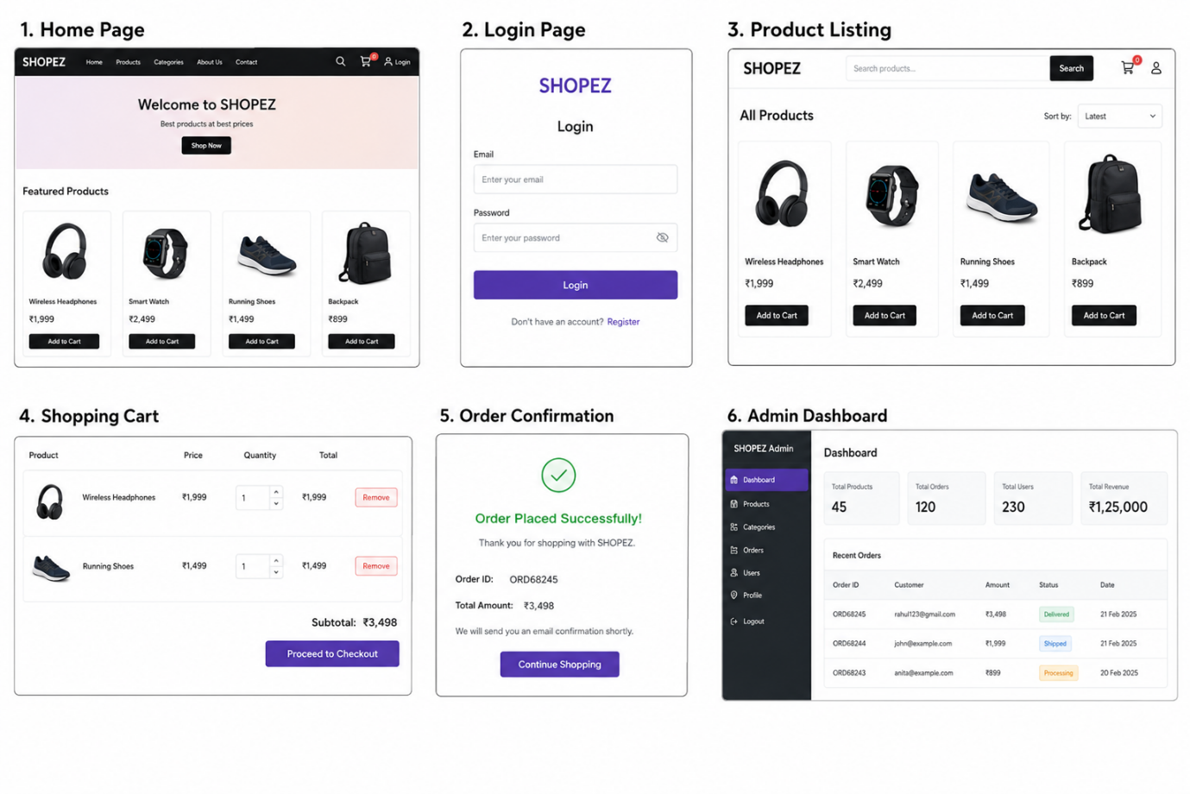
Demo Link
https://drive.google.com/file/d/16et1-yscPDsMxj9c3rPp4gD8ZqkvvZ0L/view?usp=sharing
GitHub Repository
https://github.com/illuri-nagalakshmi/ShopZECommerceWebSite

12. Known Issues
- Payment gateway is currently implemented as a prototype.
- Mobile application is not yet available.
- Wishlist notifications are not implemented.
- Email notifications are basic.
- Product recommendation system is not available.

13. Future Enhancements
Future improvements include:
- AI-Based Product Recommendations
- Multiple Payment Gateways
- Mobile Application (Android & iOS)
- Live Order Tracking
- Chatbot Support
- Product Ratings & Reviews
- Multi-language Support
- Push Notifications
- Voice Search
- Dark Mode
- Coupon & Discount Management
- Analytics Dashboard
- Seller Portal
- Inventory Prediction using AI

Technologies Used
Category | Technology
Frontend | React.js, HTML5, CSS3, Bootstrap
Backend | Node.js, Express.js
Database | MongoDB
Authentication | JWT, bcrypt
API Testing | Postman
Version Control | Git & GitHub
IDE | Visual Studio Code

Bottom of Form

